Multitier Computing (ONLY FOR TOPIC REFERENCE. MUST READ BOOK(S) FOR EXAM preparation
The midst of a fundamental change in both technology and its application.
Price / performance
The constraining factors are the organizational impact of reengineering the business process and the costs and time required for system development
Open systems enable organizations to buy off-the-shelf solutions to business problems.
Open systems standards define the format in which data is exchanged, remote systems are accessed, and services are invoked
Build reusable class libraries to use in object-oriented design and development environments
Build niche products that interact with the same data (objects).
Customize a letter at a personal desktop workstation to include data, addressing and graphics input from a word processor, a personal spreadsheet, a workgroup database, and an existing enterprise host application to be sent by electronic mail to anywhere in the world.
The client/server model makes the enterprise available at the desk
It provides access to data that the previous architectures did not.
Standards have been defined for client/server computing.
Powerful enabling technologies with built-in conformance to open systems standards are evolving rapidly.
Examples include object-oriented development, relational and object-oriented databases, multimedia, imaging, expert systems, geographic information systems (GIS), voice recognition and voice response, and text management.

Driving Forces in the 1990s
Opportunities are available to organizations and people who are ready and able to compete in the global market. A competitive global economy will ensure obsolescence and obscurity to those who cannot or are unwilling to compete. All organizations must look for ways to demonstrate value. We are finally seeing a willingness to rethink existing organizational structures and business practices.
Organizations are aggressively downsizing even as they try to aggressively expand their revenue base.
There is more willingness to continue improvement practices and programs to eliminate redundancy and increase effectiveness. Organizations are becoming market-driven while remaining true to their business vision.
To be competitive in a global economy, organizations in developed economies must employ technology to gain the efficiencies necessary to offset their higher labor costs. Reengineering the business process to provide information and decision-making support at points of customer contact reduces the need for layers of decision-making management, improves responsiveness, and enhances customer service.
Empowerment means that knowledge and responsibility are available to the employee at the point of customer contact. Empowerment will ensure that product and service problems and opportunities are identified and finalized. Client/server computing is the most effective source for the tools that empower employees with authority and responsibility.
The following are some key drivers in organizational philosophy, policies, and practices.

Business Process Reengineering
Competitiveness is forcing organizations to find new ways to manage their business, despite fewer personnel, more outsourcing, a market-driven orientation

Globalization—The World as a Market

Operational Systems—Competition for Investment Dollars

Market Driven—Flexible to Meet Needs

Downsized Organizational Structure

Enterprise Network Management

Information and Technology Viewed as a Corporate Asset

Cost Competitive—New Offerings

Increasing Power and Capacity of Workstations

Aspiring to have a Single System Image
In distributed computing, a single system image (SSI) cluster is a cluster of machines that appears to be one single system
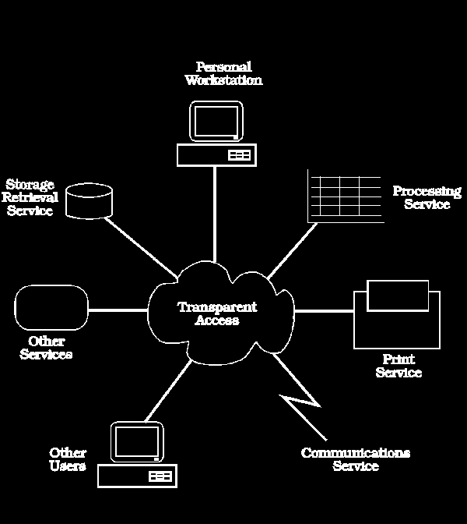
The complexity of a heterogeneous computing platform will result in many interfaces at both the logical and physical level
There is complexity and risk when attempting to interoperate among technologies from many vendors. It is necessary to engage in "proof of concept" testing to distinguish the marketing version of products and architectures from the delivered version.
Installing a proposed solution using a technology competency centerTCC is a low-cost means of ensuring that the solution is viable.These labs enable rapid installation of the proposed solution into a proven environment
Client/Server Computing

The single-system image is best implemented through the client/server model.
Because the desktop computer is the user's view into the enterprise, there is no better way to guarantee a single image than to start at the desktop
Client: A client is a single-user workstation that provides presentation services and the appropriate computing, connectivity, and database services and interfaces relevant to the business need.
Server: A server is one or more multiuser processors with shared memory providing computing, connectivity, and database services and interfaces relevant to the business need.
Client/server computing is an environment that satisfies the business need by appropriately allocating the application processing between the client and the server processors.
The client requests services from the server;
The server processes the request and returns the result to the client.
The communications mechanism is a message passing interprocess communication (IPC) that enables (but does not require) distributed placement of the client and server processes
Client/server is a software model of computing, not a hardware definition.
This definition makes client/server a rather generic model and fits what is known in the industry as "cooperative processing" or "peer-to-peer."
Because the client/server environment is typically heterogeneous, the hardware platform and operating system of the client and server are not usually the same.
In such cases, the communications mechanism may be further extended through a well-defined set of standard application program interfaces (APIs) and remote procedure calls (RPCs).
A client-user relies on the desktop workstation for all computing needs.
Whether the application runs totally on the desktop or uses services provided by one or more servers—be they powerful PCs or mainframes—is irrelevant.
Effective client/server computing will be fundamentally platform-independent. The user of an application wants the business functionality it provides; the computing platform provides access to this business functionality. There is no benefit, yet considerable risk, in exposing this platform to its user.

Modern Client Server Architecture: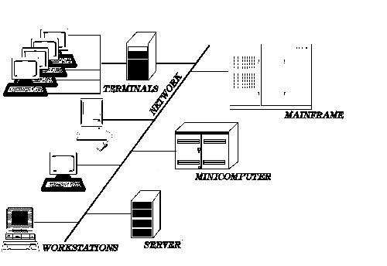
Tools, which isolate developers from the specifics of any single platform, assist developers in writing transparent, portable applications
three essential components in any application: data access, processing, and interfaces
Data access includes the graphical user interface (GUI) and stored data access.
Processing includes the business logic.
Interfaces link services with other applications
Data Access
------------------
Processing
---------------------
Interfaces
The use of technology layers provides this application development isolation. These layers isolate the characteristics of the technology at each level from the layer above and below. This layering is fundamental to the development of applications in the client/server model. The rapid rate of change in these technologies and the lack of experience with the "best" solutions implies that we must isolate specific technologies from each other.

Existing environment (before client server computing)
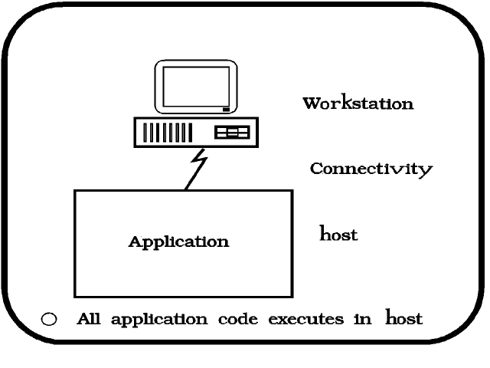
Mainframe-Centric Client/Server Computing
uses the presentation capabilities of the workstation to front-end existing applications
data is displayed or entered through the use of pull-down lists, scrollable fields, check boxes, and buttons
user interface is easy to use, and information is presented more clearly
mainframe applications continue to run unmodified, because the existing terminal data stream is processed by the workstation-based communications API
availability of products such as UniKix and IBM's CICS OS/2 and 6000 can enable the entire mainframe processing application to be moved unmodified to the workstation
This protects the investment in existing applications while improving performance and reducing costs.
Dumb terminals (earlier used in mainframe model) impose limitations on the user interface including fixed length fields, fixed length lists, crowded screens, single or limited character fonts, limited or no graphics icons, and limited windowing for multiple application display.
fixed layout of the screen makes it difficult to support the display of conditionally derived information
In contrast, the workstation GUI provides facilities to build the screen dynamically.
enables screens to be built with a variable format based conditionally on the data values of specific fields
Variable length fields can be scrollable, and
lists of fields can have a scrollable number of rows.
This enables a much larger virtual screen to be used with no additional data communicated between the client workstation and server.
Electronic data interchange (EDI) is an example of this front-end processing. EDI enables organizations to communicate electronically with their suppliers or customers. Frequently, these systems provide the workstation front end to deal with the EDI link but continue to work with the existing back-end host system applications. Messages are reformatted and responses are handled by the EDI client, but application processing is done by the existing application server.
how multiple applications can be integrated in this way. The data is available to authorized users as soon as it is captured

Intelligent Character Recognition (ICR) technology can be an extremely effective way to automate the capture of data from a form, without the need to key. Current experience with this technique shows accuracy rates greater than 99.5 percent for typed forms and greater than 98.5 percent for handwritten forms
Unit IIOpen System Standards for client server computing
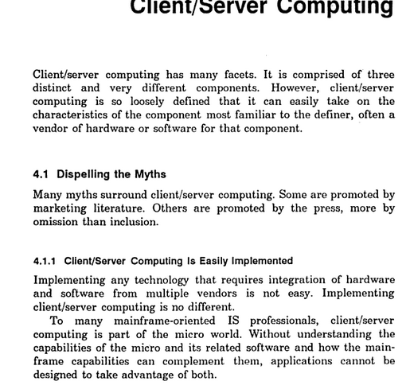
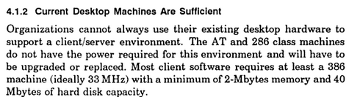
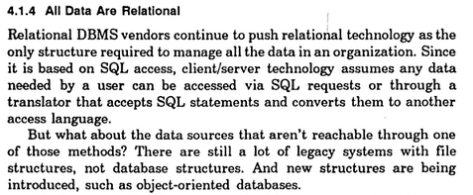
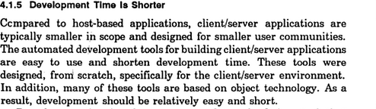
Architecture is always the same
No.
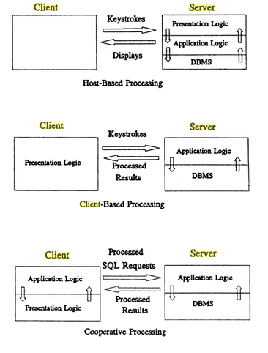

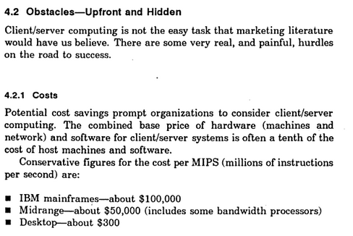
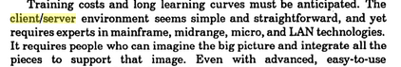
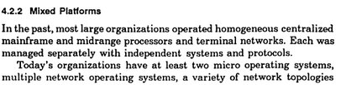

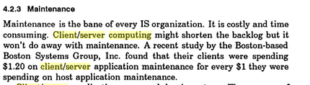

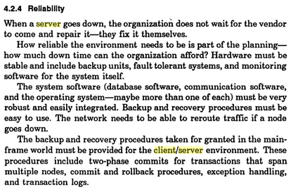

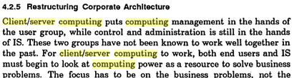

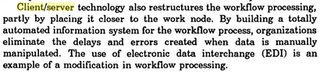

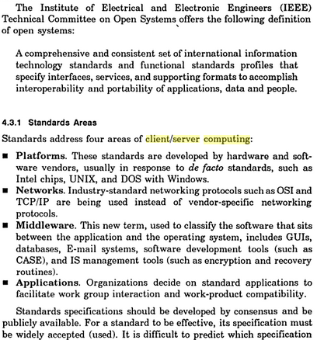
Existing Standards (OS and Networks)
- Unix
- POSIX (IEEE unix based)
- TCP/IP
- OSI (Open Systems Interconnection) – Layered n/w structure
- Remote Data Access (RDA), Distributed Rational Database Architecture (DRDA)

Why open systems:
- Conform to a broad set of formal and defacto standards
- Support for verity of vendors
- Demands strategic adoption of standards by users and developers
- Plug and play, easier development

Standards Setting Organizations:
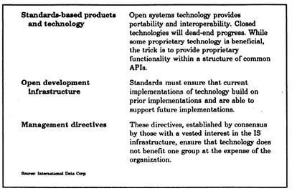
Factors for Success:
Business Motivation
Internetworking
Interoperability
Compatible environments
Perceived benefits

CLIENTS,SERVERS, AND OPERATING SYSTEMS:
The Anatomy of a server program:
Waits for client-initiated requests.
Some servers assign a dedicated session to every client.
Others create a dynamic pool of reusable sessions.
Some provide a mix of the two environments.
Must be able to handle requests without dropping
Executes many requests at the same time.
Multi threaded (sometimes additionally multi tasking) (Multi programming/multitasking/multi processing)
Priority based client request handlnig
Initiates and runs background-task activity.
Keeps running: The server program is typically a mission-critical application.
Grows bigger and fatter: Server programs seem to have an insatiable appetite for memory and processing power. The server environment must be upwardly scalable and modular.

What Does a Server Need From an OS?
Base Services

- Server programs exhibit a high level of concurrency.
Ideally, a separate task will be assigned to each of the clients the server is designed to concurrently support.
Task management is best done by a multitasking operating system.
- Multitasking is the natural way to simplify the coding of complex applications that can be divided into a collection of discrete and logically distinct, concurrent tasks.
- It improves the performance, throughput, modularity, and responsiveness of server programs. Multitasking also implies the existence of mechanisms for intertask coordination and information exchanges.
- Servers also require a high level of concurrency within a single program.
- Server code with run more efficiently if tasks are allocated to parts of the same program rather than to separate programs (these tasks are called coroutines or threads).
- Tasks within the same program are faster to create, faster to context switch, and have easier access to shared information.
- 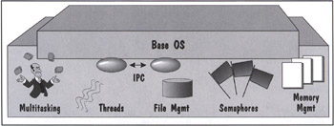

Task Preemption.

Task Priority.

Semaphores. An operating system must provide simple synchronization mechanisms for keeping concurrent tasks from bumping into one another when accessing shared resources.

Interprocess Communications (IPC). An operating system must provide the mechanisms that allow independent processes to exchange and share data.

Local/Remote Interprocess Communications.

Threads.

Intertask Protection.

Multiuser High-Performance File System.

Efficient Memory Management.

Dynamically Linked Run-Time Extensions.

Extended Services
The advanced system software that exploits the distributed potential of networks, provide flexible access to shared information, and make the system easier to manage and maintain

They also make it easier for independent software vendors (ISVs) and system integrators to create new server applications.

Ubiquitous Communications. The operating system extensions must provide a rich set of communications protocol stacks
Network Operating System Extensions. The operating system extensions must provide facilities for extending the file and print services over the network. Ideally, the applications should be able to transparently access any remote device
Binary Large Objects (BLOBs). Images, video, graphics, intelligent documents, and database snapshots are about to test the capabilities of our operating systems, databases, and networks
Global Directories and Network Yellow Pages. The operating system extensions must provide a way for clients to locate servers and their services
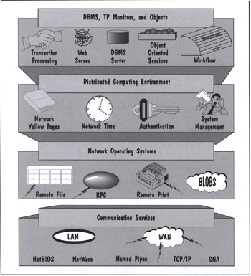

Authentication and Authorization Services
System Management. The operating system extensions must provide an integrated network and system management platform.
Network Time. The operating system extensions must provide a mechanism for clients and servers to synchronize their clocks
Database and Transaction Services.
Internet Services: http, ssl, tls, firewalls, DNS, HTML based file systems, e-commerce
Object-Oriented Services. This is an area where extended services will flourish for a long time to come. Services are becoming more object-oriented.
Extended Services does mean "extended." It covers the universe of current and future services needed to create distributed client/server environments. No current operating system bundles all these extended functions, but they're all aspiring to do so.
Server Scalability

The limits really depend on the type of service required by their clients. One safe rule is that clients will always want more services, so scalable servers are frequently an issue
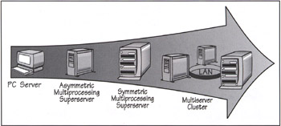

Multiservers (or clusters) are used in environments that require more processing power than that provided by a single server system—either SMP or uniprocessor (see the next Briefing box).
The client/server model is upwardly scalable. When you need more processing power, you can add more servers (thus creating a pool of servers).
Or, the existing server machine can be traded up to the latest generation of PC superserver machine
Multiservers remove any upward limits to the growth of server power.
Ordinary servers can also provide this power by working in all kinds of ensembles using middleware
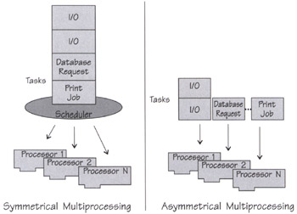
A multiprocessors server is upwardly scalable. Users can get more performance out of their server by simply adding more processors instead of additional servers

Asymmetric multiprocessing imposes hierarchy and a division of labor among processors. Only one designated processor, the master, can run the operating system at any one time
The master controls (in a tightly-coupled arrangement) slave processors dedicated to specific functions such as disk I/O or network I/O. A coprocessor is an extreme form of codependency; one processor completely controls a slave processor through interlocked special-purpose instructions. The coprocessor has unique special purpose hardware that is not identical to the main processor. An example is a graphic coprocessor.
Symmetric Multiprocessing (SMP) treats all processors as equals. Any processor can do the work of any other processor. Applications are divided into threads that can run concurrently on any available processor. Any processor in the pool can run the operating system kernel and execute user-written threads. Symmetric multiprocessing improves the performance of the application itself, as well as the total throughput of the server system
Most importantly, symmetric multiprocessing requires new applications that can exploit multithreaded parallelism
The few applications on the market that really exploit SMP are SQL DBMSs and TP Monitors.
The mass-market server operating systems—including Unix, NetWare, OS/2, and NT—all support SMP.

Clusters make a group of interconnected SMP machines behave like a single system. Typically, the interconnection is via a high-speed LAN. Clustering has been around on mainframes and Unix systems for many years. In 1997, Microsoft (and others) brought clustering to NT. The first release of the Microsoft NT Clustering Services—also known as Wolfpack—does not scale. However, it provides some level of fault-tolerance via failovers.

Typically, clusters come in one of two flavors: shared-disk and shared-nothing
In both cases, some form of high-speed LAN is used for intercluster communications; it can be a simple Ethernet connection or a specialized high-speed redundant bus
Clusters provide high-availability because they do not share memory or synchronized caches
Consequently, failures are contained within a single node
Some clustering systems use "I'm alive" messages to determine the health of each node on the cluster.
If a node dies, messages can be re-routed to an alternate node. Of course, the alternate must be capable of doing the job and must also have access to the shared data
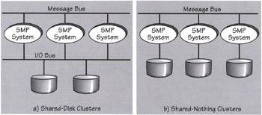
"shared-nothing" architectures eliminate the bottlenecks found in SMP systems, thus allowing them to scale to hundreds or even thousands of processor

Client Anatomy 101
- Client/server applications are client-centric.
- The client side provides the "look-and-feel" for the services a system provides.
- All client applications have this in common: they request the services of a server.
- What makes client applications different is what triggers the requests and what GUI, if any, is needed.
- Based on differences, we can classify clients into three categories (3 types of clients)
  - Non-GUI Clients, GUI Clients, and OOUI Clients
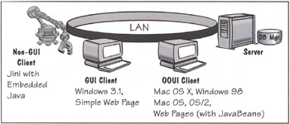
Figure 5-6: Three Client Types: Non-GUI, GUI, mad OOUI.

Non-Gui Clients
Non-GUI client applications generate server requests with a minimal amount of human interaction (see Figure 5-7). Non-GUI clients fall into two sub-categories:
- Non-GUI clients that do not need multitasking from OS
- Non-GUI clients that need multitasking from OS
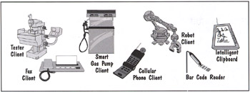
Figure 5-7: The Many Faces of Non-GUI Clients.

GUI Clients
- Simple GUI Clients are applications where occasional requests to the server result from a human interacting with a GUI.
- The simple GUI interface is a good fit for mainstream, OLTP-type business applications
- They also make good front-end clients to database servers.

Object-Oriented User Interface (OOUI) Clients
- The Object-Oriented User Interface (OOUI)provides a
  - highly iconic, object-oriented user interface
  - that lets you directly manipulate objects on a screen (via drag-and-drop).
  - OOUIs are used by information workers doing multiple, variable tasks whose sequence cannot be predicted.
  - Examples include executive and decision-support applications, multimedia-based training systems, system management consoles, and stockbroker workstations.
  - OOUIs have an insatiable appetite for communications.
  - OOUI desktop objects need to communicate among themselves and with external servers.
  - The communications are, by necessity, real-time, interactive, and highly concurrent.
Examples of OOUIs are the OS/2 Workplace Shell, NextStep (now Mac OS X), Mac OS, and, to some extent, Windows 98. In addition, you will start seeing OOUI-like Web pages populated with Java 2 JavaBeans
- Current OOUIs provide a visual desktop metaphor (think of it as an arcade game) where you can bring together related objects and programs to perform a task.
- The desktop can contain multiple workplaces running concurrently (see Figure 5-9).
- Each workplace may be running parallel dialogs, also, called modeless dialogs, over parallel sessions with the server.
- With advanced multimedia-type applications, you can use these parallel dialogs to display images, video, multiobject folders, and voice-annotated mail.
- Information is displayed to the user in the foreground windows, while background tasks are constantly moving information to and from servers.
- For example, the first page from a multimedia document is displayed in a windowwhile a background task is busy prefetching the rest of the document from the server.

- OOUIs focus on the objects required to accomplish a task.
- They provide folders, workareas, shadows (short cuts), and associations that allow users to personalize their desktops and manage their objects.
- OOUIs provide a common metaphor for creating, copying, moving, connecting, and deleting any object on the desktop.
- One of the major features of OOUIs is the concept of multiple views of objects.

Application Features: GUI Versus OOUI
- In OOUI Club Med is an extension of the operating system's user interface.
  - They appear to be seamlessly integrated.
- The OOUI allows the user to manipulate the visual objects through drag-and-drop.
  - For example, a transaction may be triggered by dragging a guest object to the shredder to delete it. Or, if we want to be kind, we'll drop it on the fax machine icon to send a confirmation of the reservation.
- The OOUI icon can be opened at any time to reveal a notebook view of the information inside it.
- The notebook control makes it possible to visually staple together many dialog windows and let the user find the information needed. This is a giant step forward for OLTP-type of applications.
- The OOUI setup will reappear the way the user left it when the machine is turned on again. The desktop configuration is persistent.
- The OOUI is very familiar, especially to kids. It feels like a video game. Kids feel quite at home with drag-and-drop, icons, and direct manipulation.
- The OOUI can be extended to seamlessly work with any other OOUI object (with very little new code).
- The GUI on the other hand, is your typical Windows or Web interface.
  - The icon is just there to represent the application to the desktop.
  - You're not invited to play with it.
  - You start the application by clicking on the icon (or on a URL link). From then on, you're in menu land.
  - The user is quite aware that there is a running application.
Table 5-1: GUI Versus OOUI.
Feature | Grapical User Interface (GUI) | Object-Oriented User Interface (OOUI)
Application Structure | A graphic application consists of an icon, a primary window with a menu bar, and one or more secondary windows. The focus is on the main task. Ancillary tasks are supported by secondary windows and pop-ups. Users must follow the rigid task structure (and may get trapped in a task). An application represents a task. | A graphic application consists of a collection of cooperating user objects. Everything that you see is an object. Each object is represented by an icon and has at least one view. Objects can be reused in many tasks. The application's boundaries are fuzzy. The user defines what's an application by assembling a collection of objects. These objects may come from one or more programs and are integrated with the desktop objects the system provides (likes printers and shredders). The users can innovate and create their own "Lego-like" object collections.
Icons | Icons represent a running application. | Icons represent object that may be directly manipulated.
Starting an Application | Users start application before selecting an object to work with. | Users open the object on the desktop, which causes a window view of the object to be displayed.
Windows | Users open a primary window and then specify the objects they want to interact with. The same window can be used to display other objects. | A window is a view of what's inside an object. There is a one-to-one relationship between a window and an object.
Menus | Menus provide the primary method for navigating within an application. | Each object has a context menu. You navigate within an application or across applications by directly manipulating objects. The desktop functions as one big menu; icons represent the objects that you can manipulate.
Active Application Visual | Icons represent minimized windows of active applications. | Icons are augmented with the in-use emphasis to represent an active object.
Direct Manipulation | An application may provide direct manipulation on an ad hoc basis. | Objects are created, communicated with, moved, and manipulated through drag-and-drop manipulation.
Creating New Objects | Objects are created in an application-specific manner, usually through some form of copy mechanism or using the menu choices: new or open. | A templates folder contains a template for every object type. To create a new instance of an object, drag its template to where you want the new object to reside.
Actions | Choose object; then choose action from menu bar. | In addition to choosing actions from menus, a user can drag objects to icons to perform operations; for example, dragging a file to a printer icon.
Containers | Text-based list boxes provide the primary form of containment. | In addition to list boxes, OOUIs provide container objects, including folders and notebooks. These in turn can contain other objects. Actions performed on container objects affect all the objects inside them.
Focus | Focus is on the main task. | Focus is on active objects and tasks.
Who Is In Control? | Control alternates between the user and the application. | All the applications behave the same and the user acts as the conductor. Think of the user as the visual programmer of the desktop.
Product Examples | Windows 3.X, Motif, and simple Web pages. | NextStep/Mac OS X, Mac OS, Windows 98, OS/2 Workplace Shell, and Web pages that take advantage of Java 2 JavaBeans.

Compound Documents: OOUIs on Steroids
Compound documents frameworks—like ActiveX and JavaBeans—are the latest and greatest OOUI technology (see Figure 5-10). You can think of compound documents as OOUIs on steroids. Every visual object on the screen is a live component. Some components are also containers, which means that they can embed other components. You can edit the contents of any component "in-place," regardless of how deeply embedded it is within other components. A component is an independent piece of software that you can separately purchase on the market. Components can play together in visual suites that mimic applications.
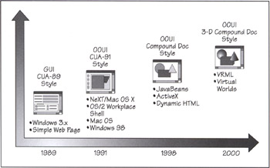
Figure 5-10: The GUI/OOUI Evolution.

Shippable Places
- A place is a visual ensemble of related components.
- A shippable place is a mobile container of components; it's a place that can be shipped over the Net.
- Today's user interfaces are centered around a primitive place that represents a desktop.
- In contrast, shippable places let you interact with multiple places that represent collaborative environments based on real-world models; it's like having multiple desktops.
- So a place is a mini virtual world that servers can ship to their clients;
- a place can be a dynamic assembly of ever-changing data, video feeds, and other live content.
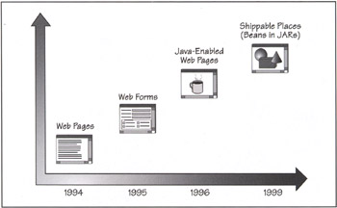
Figure 5-11: From Web Pages to Shippable Places.

What does a client need from server?
- Each of the three types of clients described here places a different set of requirements on the operating system.
- All client applications need some mechanism to communicate service requests and files to a server.
- All three client categories will function best in a robust, multitasking environment.
- It is particularly important for the client environment to be robust because it is impossible for system providers to test the client software on all possible hardware/software combinations (you can't dictate what people run on their PCs).
- It is important to use an operating system that can protect programs from clashing and crashing.
- No client program should cause the system to hang (requiring a reboot)

- GUI and OOUI clients work best with a thread-like mechanism for handling the background requests.
- Priority-based, preemptive multitasking is also required to respond to multimedia devices and to create client applications where multiple dialogs are displayed in parallel.
- Increasingly, one of the most important requirements of a client operating system is to host mobile code in a secure fashion.
- In practice, this means the client OS must provide a Java VM.

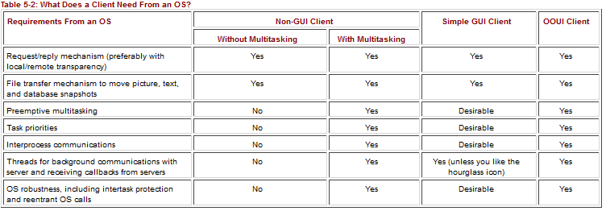

THREE-TIER COMPUTING: Introduction and comparison of two and three tier- Client side, Server side and Middleware side

Client/Server Building Blocks

Architectures help us identify structural elements that may be used as building blocks in the construction of ever-more complex systems

The "million-dollar" architectural questions are:
- How is the application split between the client and the server?
- What function goes in the client and what function goes in the server?
- Can the client/server model accommodate businesses of all sizes?
- How are the new tribes of nomadic laptop users brought into the client/server fold?
- Can client/server play in the home?
- Where do peer networks fit in this picture?
- Will client/server disappear in a post-scarcity computing world?

Client/Server: A One-Size-Fits-All Model

To meet a wide spectrum of client/server needs—from the tiny to the intergalactic—with just three basic building blocks: a client, a server, and the slash (/) that ties the client to the server

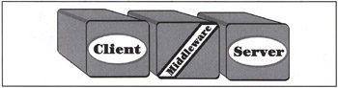

Client/server for tiny shops: building-block implementation that runs the client, the middleware software, and most of the business services on the same machine. It is the suggested implementation for the one-person shops, home offices, and mobile users with well-endowed laptops. This is a new opportunity area for client/server technology.

Easy to run the client and server portion of an application on the same machine.

The only caveat is that you need to use an operating system that is robust enough to run both the client and server

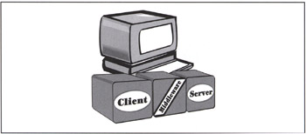

Client/server for small shops and departments is the classic Ethernet client/single-server building-block implementation. It is used in small shops, departments, and branch offices. This is the predominant form of client/server today.
- Well-suited for the LAN-based single server establishments
- account for around 70% of today's client/server installations
- It consists of multiple clients talking to a local server
- The single-server nature of the model tends to keep the middleware simple.
- client only needs to look into a configuration file to find its server's name
- Security is implemented at the machine level and kept quiet simple.
- The network is usually relatively easy to administer; it's a part-time job for a member of the group
- There are no complex interactions between servers, so it is easy to identify failures
- Possible for server to interact in a very loosely-coupled way with some enterprise server
- For example, data (such as a price list) may be downloaded once a day to refresh the local server.
- Departmental servers will continue to be popular, even in large enterprises, because they provide a tremendous amount of user autonomy and controls.
- server's applications typically address the specific needs of the local clients first, which makes users very happy
- With fiber optics and high-speed ATM connections, it will be hard to detect a performance difference between a local departmental server and an enterprise server a continent away
- This model works very well in small businesses and departments that depend on single servers or on very loosely-coupled multiserver arrangements.

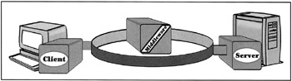

Client/server for intergalactic enterprises is the multiserver building-block implementation of client/server. The servers present a single-system image to the client. They can be spread throughout the enterprise, but they can be made to look like they're part of the local desktop. This implementation meets the initial needs of intergalactic client/server computing.
- The client/server enterprise model addresses the needs of establishments with a mix of heterogeneous servers.
- industry attention as solutions move from a few large computers to multiple servers that live on the Internet, intranets, and corporate backbone networks
- upwardly scalable
- When more processing power is needed for various intergalactic functions, more servers can be added (thus creating a pool of servers), or the existing server machine can be traded up for the latest generation of superserver machine.
- We can partition servers based on the function they provide, the resource they control, or the database they own
- replicate servers for fault tolerance or to boost an application's performance
- can provide an awesome amount of compute power and flexibility, in many cases rivaling that of mainframes
- To exploit the full power of multiservers, we need low-cost, high-speed bandwidth and an awesome amount of middleware features
- including network directory services, network security, remote procedure calls, and network time services. Middleware creates a common view of all the services on the network, called a "single-system image"
- Good software architecture for intergalactic enterprise client/server implementations, is all about creating system "ensembles" out of modular building blocks
- find creative ways to partition work among the servers.
- design your servers so that they can delegate work to their fellow servers
- A complex request may involve a task force of servers working together on the request.
- Preferably, the client should not be made aware of this behind-the-scenes collaboration
- The server that the client first contacts should be in charge of orchestrating the task force and returning its findings to the client

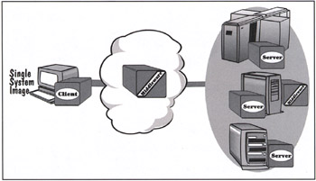

Client/server for a post-scarcity world transforms every machine in the world into both a client and a server. Personal agents on every machine will handle all the negotiations with their peer agents anywhere in the universe. This dream is almost within reach.
- what new systems can be created on a client/server platform when memory and hardware become incredibly affordable
- Every machine is both a client and a full-function server
- typical post-scarcity machine as a $2000 cellular notebook powered by a top-of-the-line processor and loaded with 100 MBytes of RAM and 100 GBytes or more of disk space.
- this machine runs all the middleware that vendors will be able to dream of over the next few years.
- Because every machine is a full-function server, we should assume it will run, at a minimum, a file server, database server, workflow agent, Object Transaction Monitor, and Web server—all connected via an ORB
- This is in addition to all the client software and middleware
- a hundred million machines or more may be running almost all the forms of client/server software

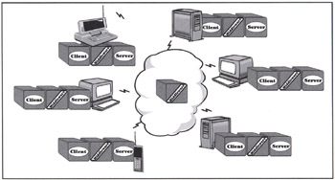

Middleware:
- The client building block runs the client side of the application
- It runs on an Operating System (OS) that provides a Graphical User Interface (GUI) or an Object Oriented User Interface (OOUI) and that can access distributed services.
- Thin clients require a Web browser to download JavaBeans and applets on demand.
- In all cases, the operating system most often passes the buck to the middleware building block and lets it handle the non-local services.
- The client also runs a component of the Distributed System Management (DSM) element.
  - This could be anything from a simple agent on a managed PC to the entire front-end of the DSM application on a managing station.
- The server building block runs the server side of the application.
- The server application typically runs on top of some shrink-wrapped server software package.
- The five contending server platforms for creating the next generation of client/server applications are SQL database servers, TP Monitors, groupware servers object servers, and the Web.
- The server side depends on the operating system to interface with the middleware building block that brings in the requests for service.
- The server also runs a DSM component.
  - This could be anything from a simple agent on a managed PC to the entire back-end of the DSM application (for example, it could provide a shared object database for storing system management information).

- The middleware building block runs on both the client and server sides of an application.
- Three categories: transport stacks, network operating systems (NOSs), and service-specific middleware.
- Middleware is the nervous system of the client/server infrastructure.
- Like the other two building blocks, the middleware also has a DSM software component.

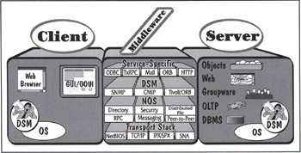

Pipes and Platforms
- The middleware boundaries have become murkier as we move to 3-tier and N-Tier client/server.
- middle-tier application may consist of hundreds or thousands of moving parts.
- middleware makes the middle-tier act as a single system (or application
- In N-tier environments, the middleware must also provide a platform for
  - running server-side components,
  - balancing their loads,
  - managing the integrity of transactions,
  - maintaining high-availability, and
  - securing the environment.
- It must also provide pipes that allow server components to communicate using a variety of metaphors.
- Of course, the middleware is still responsible for providing client/server communications pipes.
- Pipes provide the intercomponent (and interapplication) communication services.
  - Examples of pipes and RPCs, MOMs, and ORBs.
  - Pipes also include wire-level security such as SSL, as well as directory services such as LDAP.
- Platforms are the application servers that run the server-side components.
  - You can typically use them across multiple operating systems to provide a unified view of the distributed environment.
  - Examples of platforms are
    - TP Monitors, Object Transaction Monitors, and Web App Server.
    - Note that the platform for the client side is not part of the middleware equation; it is typically either a Web browser or the operating system.

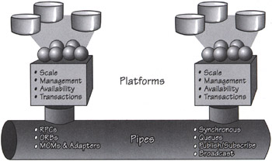

Server-to-Server Middleware
- server can play both client and server roles.
- However, some server-to-server interactions require specialized server middleware.
  - For example, a two-phase commit protocol may be used to coordinate a transaction that executes on multiple servers.
  - Servers on a mail backbone typically use special server-to-server middleware for doing store-and-forward type messaging.
  - Databases and groupware servers use daemons to automatically replicate data.

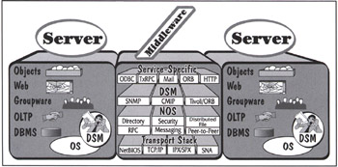

Client Requirements:
- UI design standards
- 5 user design principles: know the user, simplify repeated tasks, Provide feedback to user, be consistent, Test early and often
- Interface independence: for portability

Open interface architecture

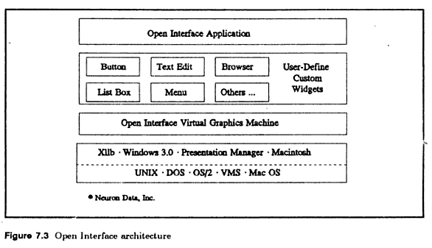
- Testing interface
- Development aids

Hardware and software requirements:

Self study from chapter 5 of Dawna book.

Transaction Servers:

Transactions:
- application design philosophy that guarantees robustness in distributed systems.
- Under the control of a TP Monitor, a transaction can be managed from its point of origin—typically on the client—across one or more servers, and then back to the originating client
- When a transaction ends, all the parties involved are in agreement as to whether it succeeded or failed.
- The transaction becomes the contract that binds the client to one or more servers.

ACID

Atomicity
- a transaction is an indivisible unit of work: all of its actions succeed or they all fail
- The actions under the transaction's umbrella may include the message queues, updates to a database, and the display of results on the client's screen.
- Atomicity is defined from the perspective of the consumer of the transaction.

Consistency
- means that after a transaction executes, it must leave the system in a correct state or it must abort.
- If the transaction cannot achieve a stable end state, it must return the system to its initial state

Isolation
- means that a transaction's behavior is not affected by other transactions that execute concurrently.
- The transaction must serialize all accesses to shared resources and guarantee that concurrent programs will not corrupt each other's operations.
- A multiuser program running under transaction protection must behave exactly as it would in a single-user environment.
- The changes that a transaction makes to shared resources must not become visible outside the transaction until it commits.

Durability
- means that a transaction's effects are permanent after it commits.
- Its changes should survive system failures.
- The term "persistent" is a synonym for "durable."

- A transaction becomes the fundamental unit of recovery, consistency, and concurrency in a client/server system.
- The application, in turn, relies on the underlying system—usually the TP Monitor—to help achieve this level of transactional integrity.
- The programmer should not have to develop tons of code that reinvents the transaction wheel.
- A more subtle point is that all the participating programs must adhere to the transactional discipline because a single faulty program can corrupt an entire system
- transaction that unknowingly uses corrupted initial data—produced by a non-transactional program—builds on top of a corrupt foundation.
- In an ideal world, all client/server programs are written as transactions.

Transaction Models:

Flat transaction:

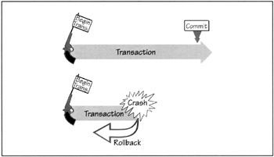

The Flat Transaction: An All-or-Nothing Proposition.
- all the work done within a transaction's boundaries is at the same level
- The transaction starts with begin_transaction and ends with either a commit_transaction or abort_transaction
- it provides an excellent fit for modeling short activities.
- The major virtue of the flat transaction is its simplicity and the ease with which it provides the ACID features.
- flat transaction model does not provide the best fit in all environments
- flat transactions using two-phase commits are usually not allowed to cross intercorporate boundaries
- A typical flat transaction does not last more than two or three seconds to avoid monopolizing critical system resources such as database locks
- OLTP client/server programs are divided into short transactions that execute back-to-back to produce results

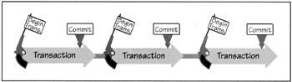

Back-to-back flat transaction

The Distributed Flat Transaction
- a flat transaction run on multiple sites and update resources located within multiple resource managers
- The programmer is not aware of the considerable amount of "under-the-cover" activity that's required to make the multisite transaction appear flat
- The transaction must travel across multiple sites to get to the resources it needs.
- Each site's TP Monitor must manage its local piece of the transaction
- Within a site, the TP Monitor coordinates the transactions with the local ACID subsystems and resource managers—including database managers, queue managers, persistent objects, and message transports

The Distributed Flat Transaction

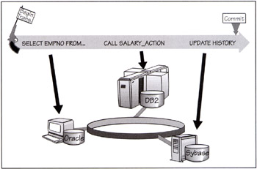

Two-Phase Commit Protocol:
- The two-phase commit protocol is used to synchronize updates on different programs and machines so that they either all fail or all succeed.
- done by centralizing the decision to commit but giving each participant the right of veto
- If none of the parties present object, the transaction takes place
- In 1993 ISO published its OSI TP standard that defines very rigidly how a two-phase commit is to be implemented

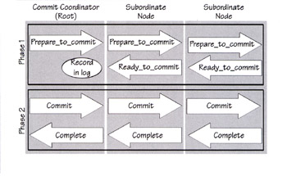
- First phase of a commit
- The commit manager node—also known as the root node or the transaction coordinator—sends prepare-to-commit commands to all the subordinate nodes that were directly asked to participate in the transaction
- The first phase of the commit terminates
- root node receives ready-to-commit signals from all its direct subordinate nodes that participate in the transaction
  - This means that the transaction has executed successfully so far on all the nodes, and they're now ready to do a final commit
- The second phase of the commit starts
- The root node makes the decision to commit the transaction—based on the unanimous yes vote. It tells its subordinates to commit.
- The second phase of the commit terminates
- When all the nodes involved have safely committed their part of the transaction and made the transaction durable.
  - The root receives all the confirmations and can tell its client that the transaction completed.
- The two-phase commit aborts
- if any of the participants return a refuse indication, meaning that their part of the transaction failed
- Limitations of two phase commit
  - Performance overhead
  - Hazard windows, where certain failures can be a problem. For example, if the root node crashes after the first phase of the commit, the subordinates may be left in disarray.

Limitations of flat transaction:
- Compound business transactions that need to be partially rolled back
- Business transactions with humans in the loop
- Business transactions with a lot of bulk
- Business transactions that span across companies or the Internet.

The Alternatives: Chained and Nested Transactions

Syncpoints, Chained Transactions, and Sagas

Syncpoints
- The simplest form of chaining is to use syncpoints—also known as savepoints—within a flat transaction that allow periodic saves of accumulated work
- The syncpoint lets you roll back work and still maintain a live transaction
- In contrast, a commit ends a transaction
- Syncpoints also give you better granularity of control over what you save and undo.
- But the big difference is that the commit is durable while the syncpoint is volatile
- If the system crashes during a transaction, all data accumulated in syncpoints is lost

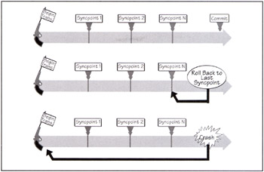

Chained transactions are a variation of syncpoints that make the accumulated work durable

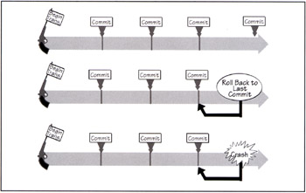
- They allow you to commit work while staying within the transaction
- But the ability to roll back an entire chain's worth of work is lost

Sagas extend the chained transactions to let you roll back the entire chain
- They do that by maintaining a chain of compensating transactions
- You still get the crash resistance of the intermediate commits,
- you have the choice of rolling back the entire chain under program control
- treat the entire chain as an atomic unit of work.

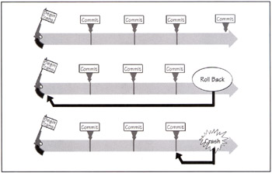

Nested Transactions
- Nested Transactions provide the ability to define transactions within other transactions.
- by breaking a transaction into hierarchies of "subtransactions"
- The main transaction starts the subtransactions, which behave as dependent transactions
- A subtransaction can also start its own subtransactions, thus making the entire structure very recursive

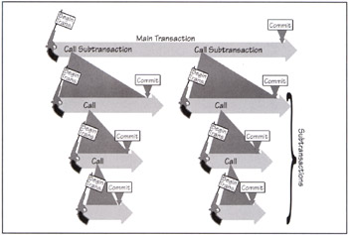

TP Monitors: Managing Client/Server Transactions

Transaction Processing Monitors (TP Monitors)
- specialize in managing transactions
- from their point of origin—typically on the client—across one or more servers,
- and then back to the originating client.
- TP Monitor ensures that all the systems involved in the transaction are left in a consistent state, at the end of a transaction
- TP Monitors know
  - how to run transactions,
  - route them across systems,
  - load-balance their execution, and
  - restart them after failures.
- overseer of all aspects of a distributed transaction, regardless of the systems or resource managers used
- A TP Monitor can manage
  - resources on a single server
  - or multiple servers,
  - and it can cooperate with other TP Monitors in federated arrangements
- TP Monitor is "an operating system for transaction processing”.
- TP Monitor also provides a framework for running middle-tier server applications and components

TP Monitor does three things extremely well:
- Process management includes starting server processes, funneling work to them, monitoring their execution, and balancing their workloads.
- Transaction management means that it guarantees the ACID properties to all programs that run under its protection.
- Client/server communications management allows clients (and services) to invoke an application component in a variety of ways—including request-response, conversations, queuing, publish-and-subscribe, or broadcast.

Why OS needs TP monitor and how is the relationship managed?

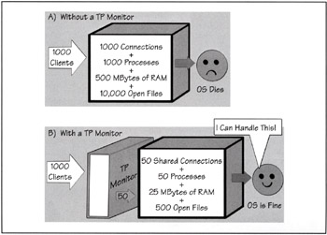

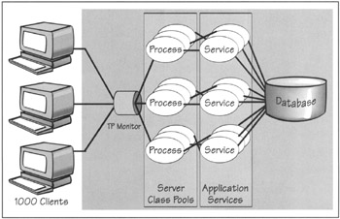

Funneling and load balancing

TP Monitor Client/Server Interaction Types

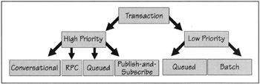

Transactional Versus Non-Transactional Communications.

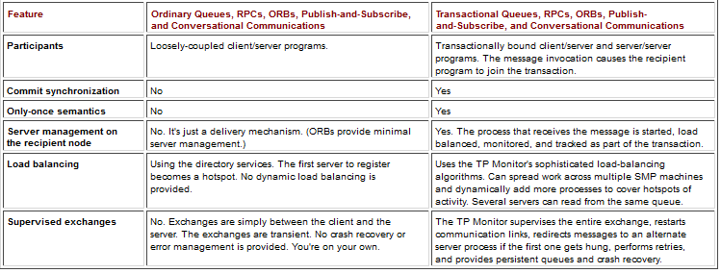

TP Monitor Benefits
- Client/Server application development framework
- Firewalls of protection
- High availability
- Load balancing
- MOM integration
- Scalabilty of function
- Reduced system cost.

TP monitors and ORBs
- ORBs bring TP Monitors to the client/server mainstream
- they will become the orchestrators of the Object Web
  - the next-generation infrastructure that combines Web and object technologies to support Internet, intranet, and extranet application
- ORBs provide TP Monitors with a myriad of standard services
  - including metadata, dynamic invocations, persistence, relationships, events, naming, component factories, versioning, licensing, security, change management, and collections.
- And objects also make it easier for TP Monitors to create and managed rich transaction models
  - such as nested transactions and long-lived transactions (or workflow).
- TP Monitors will become frameworks for managing objects packaged as transaction-savvy components
  - for example, CORBA/EJBs or server-side ActiveXs.

TP-Heavy vs TP-Lite

TP-Lite.
- SQL database managers are also in the business of managing transactions across their own resources.
- Database transactions with stored procedures is all that's needed in the area of transaction management.
- TP-Lite is simply the integration of TP Monitor functions in the database engines.

TP-Heavy
- In other cases, TP Monitors extend the notion of transactions to all resources, not just data-centric ones
- TP Monitors track the execution of functions on a single server or across servers on the network

Majority of the client/server world is TP-Less
- All these TP Monitors support the client/server architecture and allow PCs to initiate some very complex multiserver transactions from the desktop
- P-Heavy includes process management, load balancing, global transaction synchronization, interfaces to multiple resource managers, and error recovery.

Argument:
- TP-Lite systems may not solve all the world's problems, but they solve many simple ones. According to Ziph's law: most problems are simple.
- We won't have an OLTP environment manufactured by a single vendor (TP-Lite), but rather an OLTP environment that includes a mosaic of services (TP-Heavy). I think TP-Heavy will win.

TP-Lite Versus TP-Heavy: Scope of the Commit

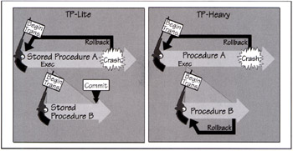
- A TP-Lite stored procedure is written in a database-vendor proprietary procedural language—PL/SQL, Transact SQL, and so on—and is stored in the database
- If stored procedure A dies after invoking stored procedure B, A's work will automatically get rolled back while B's work is committed for posterity.
- This is a violation of the ACID all-or-nothing proposition.

TP-Lite Versus TP-Heavy: Managing Heterogeneous Resources

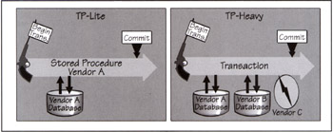
- A TP-Lite stored procedure can only commit transaction resources that are on the vendor's database or resource manager
- cannot synchronize or commit work that is on a foreign database or resource manager—whether local or remote

TP-Lite Versus TP-Heavy: Process Management
- A TP-Lite stored procedure gets invoked, executed under ACID protection (within a single-phase commit), and may then be cached in memory for future reuse
- In contrast, TP-Heavy processes are prestarted and managed as server classes

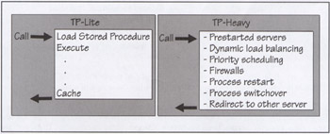

TP-Lite Versus TP-Heavy: Client/Server Invocations
- The TP-Lite stored procedure invocation is extremely non-standard. Vendors provide their own proprietary RPC invocation mechanism.
- TP-Lite does not support communications alternatives like conversations, queues, or publish-and-subscribe
- TP-Heavy environment is very open to different communication styles

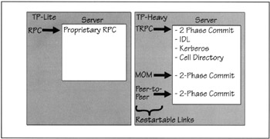

TP-Lite Versus TP-Heavy: Performance
- TP-Lite stored procedures are much faster than networked static or dynamic SQL
- They don't perform as well as TP-Heavy managed procedures, especially under heavy loads
- Most stored procedures dynamically interpret each SQL statement for each transaction and then recreate the access plan.
- In addition, most stored procedures are written using interpreted 4GLs, which are slow

TP-Lite Versus TP-Heavy: Resources& Cost

